FORGING TECHNOLOGY FORUM

International Conference & Exhibition on

**For Forging Industry**

1-2-3 December 2023 (Friday to Sunday)

Venue : Chennai Trade Centre, Chennai, India

**ADVERTISEMENT BOOKING FORM**

By Online/NEFT/UPI Amount in Rs …………………………………… in words …………………………………………..………………………

(Please send payment made details by mail)

Towards Advertisement Charges in favour of **“Foundry & Forge Training Centre”** payable at Pune. Please print our advertisement in the following category (Tick the appropriate box)

|  |  |
| --- | --- |
|  | **Technical Volume** |
| **Front Cover** |  |
| **Back Cover** |  |
| **Front Inside** |  |
| **Back Inside** |  |
| **Full Page (Multi-colour)** |  |

* For colour advertisement, material should be in suitable formats like CorelDraw (Open file),

PDF (for Press), JPEG or TIFF (high resolution).

* The size of the advertisement should not be more than specified size.
* Last date for receiving the advertisement is **30th October 2023**

Necessary advertisement material is enclosed herewith in the format specified by you.

Kindly confirm the receipt

Name & Designation..........................................................................................................................................

.............................................................................................................................................................................

Company Name..................................................................................................................................................

Address.............................................................................................................................................................................................................................................................................................................................................

Telephone.............................................................................................. Mobile ................................................ E-mail .........................................................................................................

GST No.: ................................................................... Website: .........................................................................

Invoice to be raised in the name & address (In Case Different)

........................................................................................................................................................................

........................................................................................................................................................................

Signature: ..................................................

Date: .........................................................

**RTGS / NEFT Details**

Account Name : FOUNDRY & FORGE TRAINING CENTRE

Bank Name : Uco Bank

Branch Name : Deccan Gymkhana Branch, Pune

Account No. : 06870200000612

IFSC Code : UCBA0000687

MICR : 411028009

Type of A/c : Current

GSTN : 27AAATA7701J1ZU

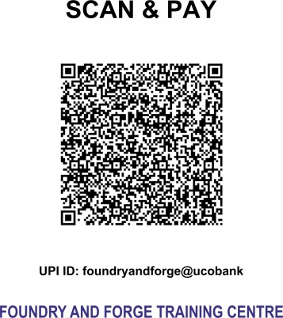

**Please fill up the form and send to:**

**FOUNDRY AND FORGE TRAINING CENTRE**

A Division of ARKEY TECHNICAL TRAINING & RESEARCH INSTITUTE (TRUST)

‘Guruprasad’, 37 / 4 / A, 6th Lane, Prabhat Road, Pune 411 004 India

+91 20 2567 0808 / 2567 2555 | +91 9764711315 |

**fftc@arkeycell.com, admin@arkeycell.com | www.forgingtechnologyforum.org**