**Exhibitor’s Manual**



**FORGING 2023**

International Conference & Exhibition on

**for Forging Industry**

**1-2-3 December 2023**

**(Friday to Sunday)**



**Venue**

**Chennai Trade Centre**

**Chennai, India**

**ORGANISED BY**



**CONCURRENT EVENT**



|  |  |  |
| --- | --- | --- |
|  | **INDEX** |  |
| **Sr. No.** | **Description** | **Page No.** |
| 1. | Contents | 2 |
| 2. | Layout | 4 |
| 3. | Details of :Event Manager, Dates & Venue, Exhibition Hours | 6 |
| 4. | Entry To Exhibition Site, Exhibition Office, Exhibition Halls & Stand Possession | 7 |
| 5. | Information Of The Officials Attending Inaugural Function, Registration As Delegate, Exhibitor Badges, Publicity,  Advertisement In Exhibition Catalogue | 8 |
| 6. | Stand Erection, Display And Decoration Guidelines,  Approval Of Layout Plans Of Stands, Supply Of Electric Power | 9 |
| 7. | Compressed Air & Water, Privileges of constructed stalls | 11 |
| 8. | Sample Stall, Safety Measures, Arrival And Installation Of Exhibits | 12 |
| 9. | Site Handling Of Exhibits, Security, Conservancy, Other  Services & Facilities | 13 |
| 10. | Terms & Conditions For Temporary Import Of Exhibits,  Removal Of Exhibits, Exit Pass Procedure & Stalls Designer details | 14 |
| 11. | Insurance of Event, Photographs & Films, Force Majeure | 15 |
| 12. | Exhibition Furniture Catalogue & Electricals & Others | 16 |
| 13. | Price list of extra Furniture and other items | 21 |

## ANNEXURES

|  |  |  |  |
| --- | --- | --- | --- |
| **Sr. No.** | **Description** |  | **Page No.** |
| 1. | Technical Specification Of Machinery Display Hall | Annexure I | 23 |
| 2. | Display And Stand Decoration Guidelines | Annexure II | 23 |
| 3. | Tariff Of Site Handling Charges | Annexure III | 26 |
| 4. | Advertisement Tariff & Conference Registration Fees | Annexure IV | 27 |

**ORDER FORMS**

|  |  |  |  |
| --- | --- | --- | --- |
| **Form No.** | **Description** | | **Return By** |
| 1 | | Stand Possession For Machinery | **15th October 2023** |
| 2 | | Stand Possession For Constructed Stalls | **15th October 2023** |
| 3 | | Advertisement Booking Form | **15th October 2023** |
| 4 | | Requirement Of Electrical / Air / Water | **15th October 2023** |
| 5 | | Extra Requirements | **15th October 2023** |
| 6 | | Information Of The Officials Attending Inaugural  Function | **15th October 2023** |
| 7 | | Exhibitor Badges | **30th October 2023** |
| 8 | | De Delegate Registration Form | **30th October 2023** |
| 9 | | Electrical Work Completion Report | **30th November 2023** |
| 10 | | Exit Pass | **3rd December 2023** |

**Exhibition Layout**

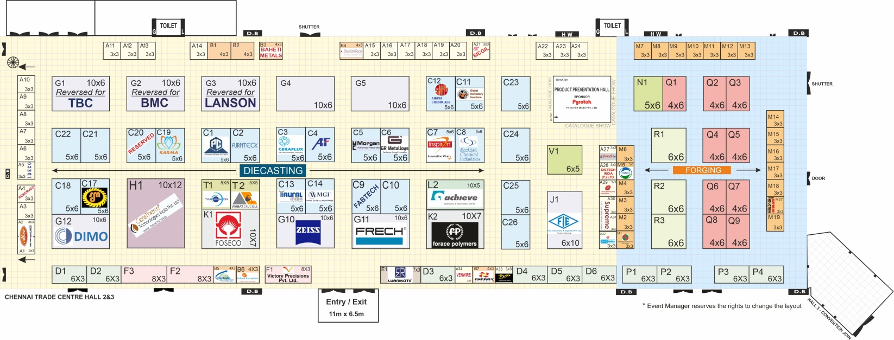

**STALL DETAILS : - FORGING 2023**

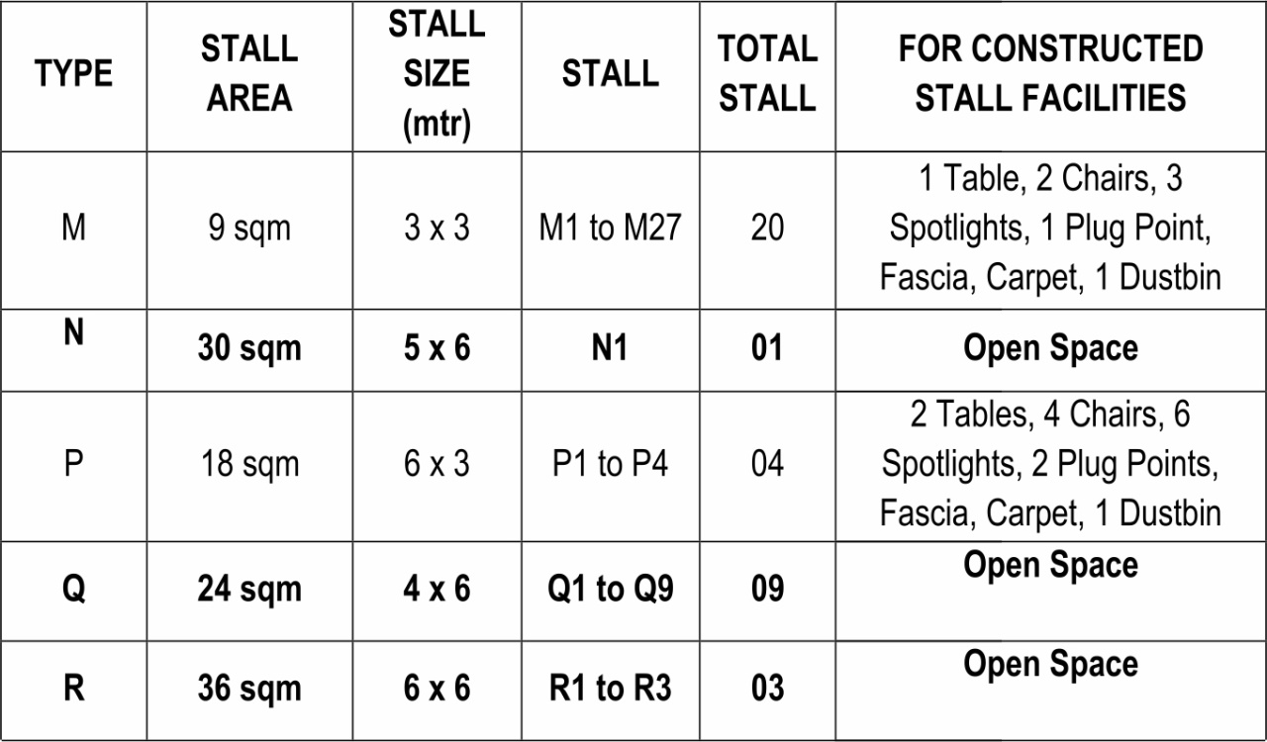

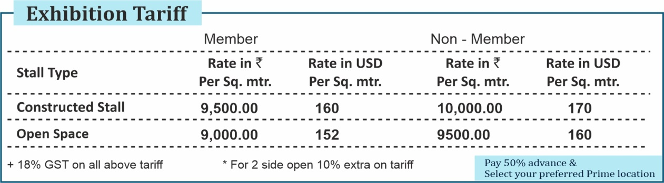

## Event Manager

* **Address - ARKEY CONFERENCE & ENGINEERING SERVICES, PUNE**

‘Guruprasad’, 1st Floor, 37/4/A, 6th Lane, Prabhat Road, PUNE - 411 004, INDIA

|  |  |
| --- | --- |
| Tel.: | +91 20 2567 0808, 2567 2555 |
| Mobile: | +91 9764711315 |
| Email: | fftc@arkeycell.com, admin@arkeycell.com |
| Website : | www.forgingtechnologyforum.org |

**Contacts and Mobile Nos. :-**

|  |  |
| --- | --- |
| Director  ARKEY CONFERENCE & ENGINEERING SERVICES  **Mr. R. T. Kulkarni** | 09422016768 |
| Exhibition Committee FORGING 2023  **Mr. Y. S. Gowaikar**- Chairman | 09822012226 |
| **Mr. Mukund Shirolikar -** Member | 09881465856 |
| **Mr. Abhay Chauthai -** Member | 09881475941 |
| Event Coordinator  ARKEY CONFERENCE & ENGINEERING SERVICES  **Mrs. Anjali Garde** | 09422016770 |
| **Event Manager Office**  **Bhagyashree** | 09764711315 |

* All communications should be sent to the address mentioned above unless otherwise mentioned.

## DATES & VENUE

**1-2-3 December (Friday to Sunday) 2023 | Venue : Chennai Trade Centre, Chennai, India**

## EXHIBITION HOURS

**Inauguration: 10:30 a.m. on 1st December 2023**

**Timing for Exhibition: 1st Dec 2023 09.30 to 18.00 Hrs.**

**2nd Dec 2023 09.30 to 18.00 Hrs.**

**3rd Dec 2023 09.30 to 17.00 Hrs.**

## ENTRY TO EXHIBITION SITE (FOR TAKING POSESSION)

* 1. **For machinery display / Open Space holders -** on **29th November 2023**

From 10.00 a.m. onwards Machinery should reach at site on **29th November 2023**

* 1. **For Constructed stall holders - 30th November 2023**

All exhibitors should inform the approximate time of their arrival to organizers by 15th November 2023. If the exhibitors fail to take possession by 7.00 p.m. on **29th November 2023** organisers are free to allot the stall to the other prospective participants. **The authorised person taking stall possession should carry a rubber stamp of the company & letter of authorisation on Company Letterhead.**

If exhibitor has appointed contractor for stall decoration and installation, the concerned person should carry letter of authorisation of the company (Two Copies).

## EXHIBITION OFFICE

The exhibition office will operate from the exhibition site, Chennai Trade Centre, Chennai, India. from **29th November 2023 from 10.00 am onwards** For contact details refer page no. 6.

## EXHIBITION HALLS

Technical specifications of all the halls are available in **ANNEXURE I.** Exhibitors are advised to refer to this information especially in context of exhibit placement / handling.

## ADMINISTRATION OF EXHIBITION HALLS

The administration of exhibition halls will be controlled by Event Manager. Exhibitors should contact the Event Manager for any assistance during the exhibition.

The Event Manager will have full authority to enforce all rules and regulations related to the exhibition. The decision taken by event manger will be final and binding in all respects, for all concerned.

## STAND POSSESSION

Exhibitors must submit the Stand Possession Form **(Form No. 1 or 2)** enclosed with this manual to the Event Manager and obtain Space/Stall Possession.

## Stall will be handed over to exhibitors by Event Managers provided the exhibitor has cleared all payments towards participation.

1. **INFORMATION OF THE OFFICIALS ATTENDING INAUGURAL FUNCTION**

Please send the information of the persons attending the Inaugural Function (Submit Form No. 6)

**Please note that invitations will be only for inaugural function & not for conference or any other event.**

1. **REGISTRATION AS DELEGATE**

If any exhibitor wants to attend the conference, he needs to register as a delegate by payment of delegate fees separately.

## EXHIBITORS' BADGES

Exhibitors will be given free badges for the stall in charge / Stall executives:-

The exhibitors should inform the names of the stall managers to prepare the badges before

**31th October 2023.**

Exhibitor should use the Exhibitor Badges Form **(Form No. 7)** for this purpose. These badges will not be mailed. Badges will be handed over only to the authorised representatives of exhibitors at the time of taking possession of stall.

Exhibitors are responsible for the safe custody of the badges. For reasons of safety, possession of exhibitor badges by unauthorised persons is strictly prohibited. **Use of blank badges / Visiting Cards as Badges will not be permitted.**

## PUBLICITY

The Event Manager will undertake general publicity of the exhibition. Exhibitors may carry out their own publicity independently at their own cost. Exhibitors are not allowed to use exhibition site for publicity without prior approval of Event Manager. Distribution of printed pamphlets outside the stall / hall and publicity by / of non-exhibitor is strictly prohibited.

## ADVERTISEMENT IN EXHIBITION CATALOGUE / TECHNICAL VOLUME

Event Manager will publish Exhibitor’s Company Profile with Logo in Exhibitor’s Catalogue. This will serve as a ready reckoner for visitors during the exhibition. Considering its wide circulation exhibitors are encouraged to release advertisements in the Exhibitor’s Catalogue/ Technical Volume. **(Form No. 3).** Please refer Annexure IV for Advertisement Tariff.

1. **STAND ERECTION, DISPLAY AND DECORATION GUIDELINES for Open Space holder**

Exhibitors are advised to strictly follow the stand erection, display and decoration guidelines specified by Event Manager. A copy of these guidelines is given in **ANNEXURE II** for reference. Particular emphasis should be given to the following aspects.

* Stands should be constructed according to the layout approved by the Event Manager
* Exhibitors should leave minimum 30% of stall area free for movement of visitors.
* Stands should be complete in every respect by 7.00 p.m. on **30th November 2023.**
* For maintaining the overall uniformity of the exhibition, height specification for panels, office walls, and show cases should be followed strictly. Deviation from the conditions of wall height is strictly prohibited.

If the exhibitors appoint external agency for stall erection, then they must ensure cleaning of their area after completion of stall work. If they do not clean it we will charge cleaning charges Rs. 500/- per hour basis.

In case construction guidelines are violated the Event Manager will take corrective measures at the risk and cost of exhibitors. Charges for such modifications will have to be borne and paid by the exhibitors before closure of the exhibition.

Exhibitors should advise their display and advertising agencies about the rules and guidelines for stall decoration and display. The Event Manager shall not correspond with display and advertising agencies. Exhibitors may seek information and clarification directly from the Event Manager.

1. **APPROVAL OF LAYOUT PLANS –Open Space Holder**

Exhibitors are required to submit the design and drawing of their stall in duplicate to the Event Manager by **12th November 2023**

1. **SUPPLY OF ELECTRIC POWER**

The electric power supply available at the exhibition is as under:

Supply Voltage available is 415 Volt, ± 10%, 3 Phase, 4 wires, 50 Hz, & 230 Volt, 1 Phase.

If any exhibitor requires other than above specification, he is advised to contact Event Manager in Advance for making the suitable arrangements.

1. The fluctuation in the parameter for power supply mentioned above is only for reference. Larger variations cannot be ruled out.
2. Exhibitors are advised to install equipment like Voltage Stabilizers/CVTs/UPS Isolation Transformer for their sensitive machine exhibits. If the machines are sensitive to the alignment of the floor, exhibitors are recommended to take necessary steps for proper leveling, alignment etc.
3. Event Manager’s personnel responsible for supply of power have been entrusted with the authority to regulate and control power supply to the Exhibition Halls and individual stands.
4. Each stand will be provided with electric power at one or more main points depending on the total requirement. Exhibitors should use Fuse Distribution Boards for feeding power to their machines. Individual isolation switches should be provided for each machine. Exhibitors should use either armored cables or metal conduits for connecting power supply to machines. All machines should be earthen firmly at two places through bare copper earthing wire of the size appropriate to the load connected to the machines. Extension wire has to be brought by the exhibitors.
5. The work of drawing power from main point(s) given in the stand area to machines/ exhibits is to be carried out by the exhibitors at their own cost. Exhibitors may engage the services of their own personnel for cabling work inside their stand subject to the condition that these personnel are duly licensed to undertake electrical work and their names and addresses are intimated to the Event Manager before the commencement of work. He should provide the license if required. The service charges of electrical contractors are to be borne by the exhibitors and are payable directly to the contractors.
6. Exhibitors should connect power to machines/ exhibits as per the requirement given in their application form. Connecting power to exhibits other than those mentioned in the application or more than the specified load or the load allotted by the Electrical Department is strictly prohibited. Personal/Individual Generator sets are not allowed.
7. Exhibitors must install separate and independent switch connections for their machines / exhibits. Alternate connections or throw-over switches are not allowed.
8. Exhibitors requiring Single Phase power for lighting purpose should carry out necessary wiring from 3 phase outlet through two pole Single Phase switches, if necessary, for further distribution.
9. After the electric wiring work is completed the exhibitors should obtain a completion report from their electricians or contractors engaged by them and file the same with the Event Managers. Actual connected load for the individual machines/ exhibits should be mentioned in the report.
10. All main electrical supply points must be kept easily accessible for operation and repairs, in the event of emergency. These should not be concealed or covered.
11. Exhibitors will fill up the Electrical Work Completion Report form as in **Form No. 9** after completion of their stall wiring work and hand over the same to the Exhibition office by 7.00 pm on 30th November 2023.
12. Exhibitors are advised to take highest level of safety precautions and engage service of only qualified personnel for electrical wiring and installations. Event Manager does not take any liability for actual happening at site.
13. Under no circumstances. Exhibitors will be permitted to reduce their electricity requirement.
14. **COMPRESSED AIR & WATER**

Exhibitors who have applied for compressed air and/or water connection will be provided with outlets for compressed air and/or water connection near the space allotted to them. Exhibitors will have to arrange connection to the machines from the source provided at their own cost**. (Ref. Form No. 4).** Available compressed air pressure 6 bar only.

1. **FOR CONSTRUCTED STALLS**

Furniture included in the stall as per the Details:

Exhibitors must submit the stand position **Form No. 2**

**Privileges for Stalls:**

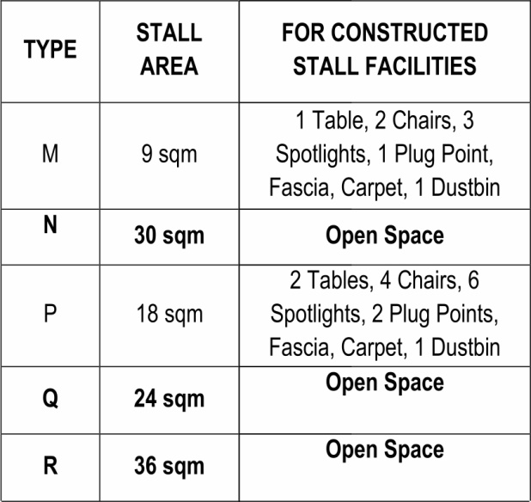

Service Provider:



**DEKO EXHIBIT SOLUTIONS LLP**

44, Mount Poonamallee Road, Nandambakkam, Chennai - 600 089

Mr. S. T. Srikumar Mobile: +91 98410 14833 | Email Id: sri@dekoexhibit.com

Mr. K. Aravindhan Mobile: +91 98410 14866 | Email Id: [aravind@dekoexhibit.com](mailto:aravind@dekoexhibit.com)

**Visible graphic area on System panel will be: 950mmx2380 mm**

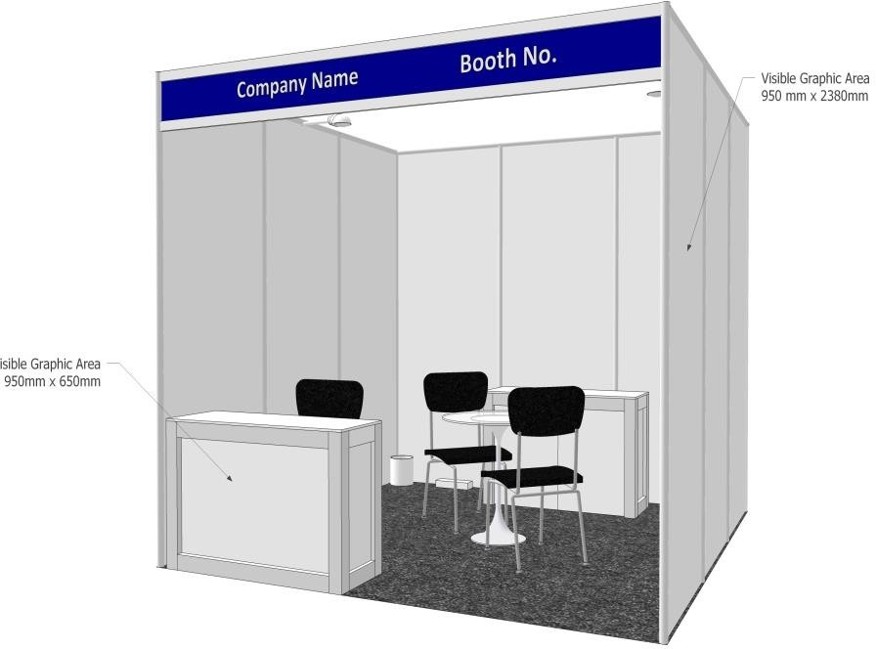

1. **SAFETY MEASURES**

Fire fighting equipment will be installed at various points near the Exhibition sites. Exhibitors are however advised to take due precautions and provide necessary equipment in their own stands. Exhibitors should also install guards or protectors on machine exhibits during demonstration to avoid injury or damage by flying chips; spark, heat, splashing of all oil etc.

Exhibitors are advised to keep their stands clean even during setting-up and dismantling periods. Exhibitors are expected to remove all discarded materials at frequent intervals, placing the same in the aisles, piled up next to the stand. Exhibitors should not delay in unpacking materials and should ask official site handling agency to immediately remove packaging from the exhibition hall, bearing in mind that packaging materials are potential fire risk.

Place will be provided by the Event Manager to store the boxes/Packing material. It is forbidden to use, electric fires with elements or other electrical appliances of the kind.

1. **ARRIVAL AND INSTALLATION OF EXHIBITS**

Exhibitors must inform the date of exhibits reaching the exhibition site in advance to the approved handling agency to plan the movement at exhibits site. Exhibits must arrive at Exhibition Site as per the schedule given below, failing which a late arrival surcharge @ 20% of basic handling charges will be levied by the handling agency.

**Heavy Goods / machinery should reach at site on 28th November 2023 Evening: 06.00 pm onwards till 29th November morning upto 09.00 am**

Exhibits arriving late may also be denied entry at the exhibition site by the Event Manager, if they are found to obstruct Exhibition operation schedules. The Event Manager's decision will be final and binding in this regard, in all respects and for all concerned.

1. **SITE HANDLING OF EXHIBITS**

Event Manager has appointed following agency for material handling at the site.

**ORIENT MARINE LINES**

49, Rani Jhansi Road,

New Delhi- 110055

Tele .: + 91 11 23514050 / 23514040 / 43584062

**Contact Person:**

Mr. Sanjay Kulkarni

Cell No. : +91 98100 57414

E-mail: [sanjayk@orientm.com](mailto:sanjayk@orientm.com)

Mr. Romesh Atre

Pune Office

Cell No. : +91 9890974142

E-mail: romesh@orientwarehousing.com

**Exhibition material at exhibition can be handled only by official agencies.**

**Exhibitors are requested to contact above handling agency for their guidelines manual or request to organisers.**

1. **SECURITY**

Event Manager will arrange for general security of the exhibition site. Exhibitors are advised to co-operate by paying the greatest attention to materials, goods, and articles belonging to them that are exhibited, and never leave stands unattended by their staff. During night, valuables must be kept in safes, cupboards, glass cases, locked drawers or the like. After the exhibition hours Halls will be locked & reopened in the morning at 8.30 am.

1. **CONSERVANCY**

Event Manager will provide for the daily clean-up of the common areas. Exhibitors are advised to keep waste bins for storing metal chips and other waste material in their own stalls. The appointed conservancy agency will clean aisles and public areas in the exhibition halls during the evening time. Exhibitors are advised to stack the trash containers outside the stand on the aisles, which will be emptied by the official agency during night.

## OTHER SERVICES & FACILITIES

* Information
* Vending machines for Drinking water, Tea and Coffee in exhibition hall.
* VIP Lounge near the Conference Hall.
* Car parking at Premises.
* First aid services
* Fire Brigade Services
* Restaurant, Lunch packs and Fast Food Services at the venue
* Representatives of Florist, Site Handling Agencies, and Photographer will be located in the foyer.

**28. TERMS & CONDITIONS FOR TEMPORARY IMPORT OF EXHIBITS**

Under the Customs Notification No. 3/89 dated 09.0.1989 and 157/90, import of Exhibits for FORGING 2023 : As per the conditions stipulated in this notification, details and provision there of will be provided by ORIENT MARINE LINES PVT.LTD on demand.

## REMOVAL OF EXHIBITS

Exhibitors are allowed to remove exhibits from their stands only after the exhibition is over i.e.; on **3rd December 2023 after 5.00 pm to 11.00 pm** After this date, the Event Manager will be at liberty to remove and store the goods at other places at the cost and risk of exhibitors. Exhibitors who are displaying heavy machineries please inform the M/s orient Marine lines regarding any specific schedule.

## EXIT PASS PROCEDURE

**For taking out exhibition material and exhibits after the closure of the exhibition, exhibitors would need an exit pass duly authorised by the Event Manager. The following procedure would be observed. Exhibitor should fill in the Exit Pass as given in Form No.10 and submit. Three copies on their letterheads to the Hall Managers in their Halls. The Hall Manager will retain one copy and return two copies duly stamped. One copy should be submitted to the security of the Hall gate and one copy is to be retained by the exhibitor (Triplicate).**

**Exit Passes will be issued to exhibitors only if all dues towards participation charges have been fully paid by the exhibitor and all the formalities stipulated from time to time are completed by the exhibitor.**

## INSURANCE OF EVENT

Exhibitors are advised to take Insurance Policy covering the following:

* + Machinery
  + Transit, loading & unloading of machine
  + Exhibitor's personnel including contractors personnel
  + Third party (visitors) risk

Organisers or Event Manager will not be responsible for any damage/ losses/ theft of property of exhibitors and injury to their personnel or visitors.

## PHOTOGRAPHS & FILMS

The Event Manager has exclusive rights to take photographs and films of the Exhibition stands. Exhibitors will have to take prior permission of the other stall holders if anyone wishes to take photographs of other exhibits/exhibitors. Exhibitors may however take photographs on their own stands and visitors.

## FORCE MAJEURE

Under the conditions of Force Majeure which also include strike, lockout, closure, riot, terrorist attack, pandemic situation, natural calamities, and other events & decisions beyond the control of the Event Manager, the Event Manager reserves the right to alter the opening and duration or even cancel the entire exhibition. In case of change in dates and duration of the Exhibition, the rules and regulations and the agreement between the Exhibitors and the Event Manager will remain unaffected. In case of cancellation of the Exhibition, the Stall rental will be refunded to the Exhibitors after deducting the non-recoverable proportionate costs already incurred by the Event Manager.

Exhibitors are warned not to keep or store any hazardous material in the stall/space occupied by them.

Any dispute between the organisers and exhibitors is subject to the jurisdiction of the Courts of Pune only. In case of unpaid charges, the organisers shall exercise the right of lien over the property of the exhibitor till he clears his dues.

1. **EXHIBITION FURNITURE CATALOGUE**

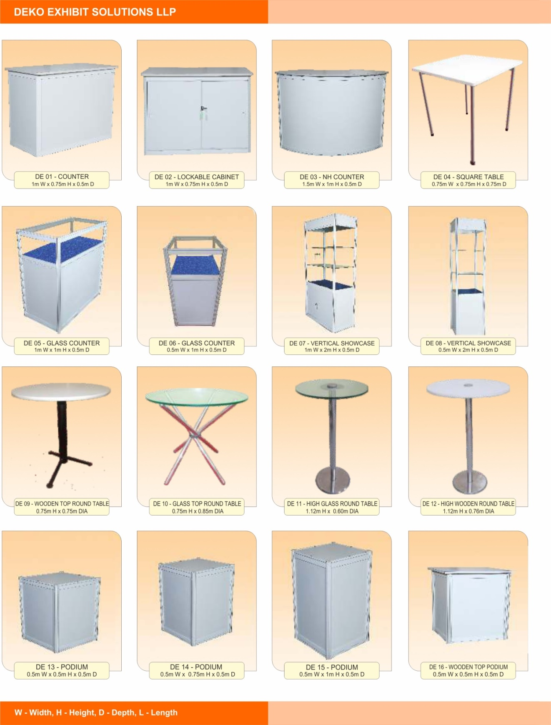

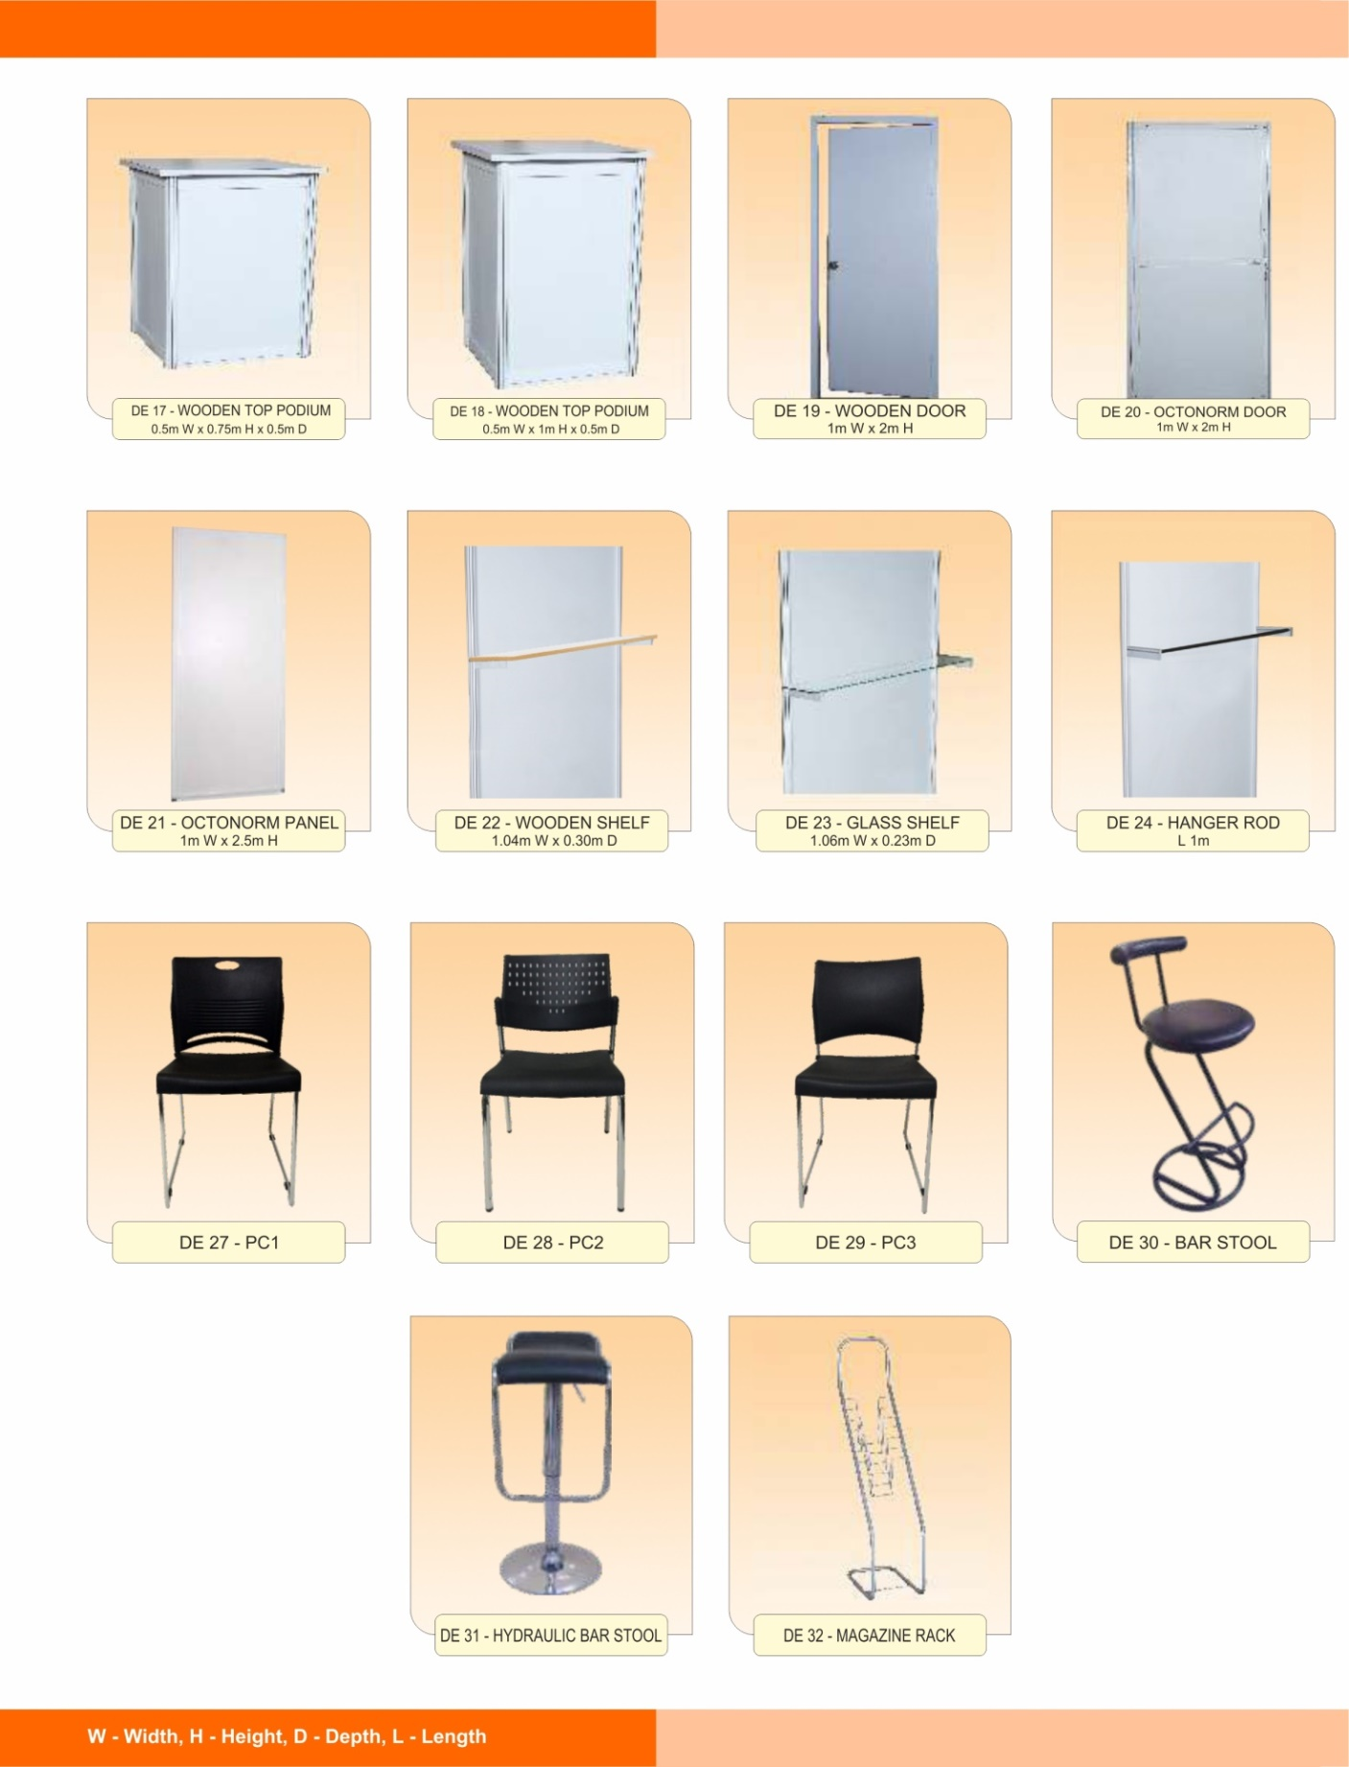

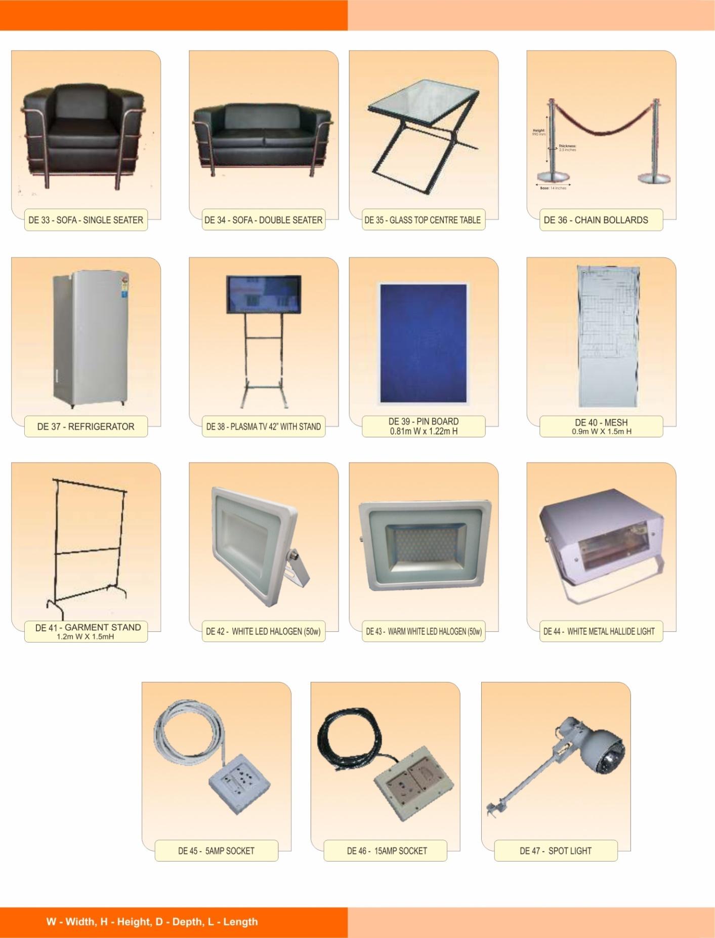

|  |  |  |  |
| --- | --- | --- | --- |
|  | | | |
| **36. FURNITURE & OTHER ITEMS - PRICE LIST** | | | |
|  | **FORGING - 2023** |  |  |
| **Code No** | **Particulars with Dimension** | **Rate (Rs.)** | **Rate (USD)** |
|  |  |  |  |
| DE 01 | COUNTER | 800.00 |  |
| DE 02 | LOCKABLE CABINET | 1,750.00 |  |
| DE 03 | NH COUNTER | 2,250.00 |  |
| DE 04 | SQUARE TABLE | 1,000.00 |  |
| DE 05 | GLASS COUNTER | 2,000.00 |  |
| DE 05a | GLASS COUNTER with LED light | 2,750.00 |  |
| DE 06 | GLASS COUNTER | 1,750.00 |  |
| DE 07 | VERTICAL SHOWCASE | 5,000.00 |  |
| DE07a | VERTICAL SHOWCASE with LED light | 5,750.00 |  |
| DE 08 | VERTICAL SHOWCASE | 4,750.00 |  |
| DE 09 | WOODEN TOP ROUND TABLE | 900.00 |  |
| DE 10 | GLASS TOP ROUND TABLE | 1,250.00 |  |
| DE 11 | HIGH GLASS ROUND TABLE | 2,000.00 |  |
| DE 12 | HIGH WOODEN ROUND TABLE | 1,500.00 |  |
| DE 13 | PODIUM | 750.00 |  |
| DE 14 | PODIUM | 1,000.00 |  |
| DE 15 | PODIUM | 1,250.00 |  |
| DE 16 | WOODEN TOP PODIUM | 1,000.00 |  |
| DE 17 | WOODEN TOP PODIUM | 1,250.00 |  |
| DE 18 | WOODEN TOP PODIUM | 1,500.00 |  |
| DE 19 | WOODEN DOOR | 3,500.00 |  |
| DE 20 | OCTONORM DOOR | 2,000.00 |  |
| DE 21 | OCTONORM PANEL | 750.00 |  |
| DE 22 | WOODEN SHELF | 350.00 |  |

|  |  |  |  |
| --- | --- | --- | --- |
| **FURNITURE & OTHER ITEMS - PRICE LIST** | | | |
|  | **FORGING - 2023** |  |  |
| **Code No** | **Particulars with Dimension** | **Rate (Rs.)** | **Rate (USD)** |
| DE 23 | GLASS SHELF | 450.00 |  |
| DE 24 | HANGAR ROD | 350.00 |  |
| DE 27 | CHAIR - PC 1 | 500.00 |  |
| DE 28 | CHAIR - PC 2 | 500.00 |  |
| DE 29 | CHAIR - PC 3 | 500.00 |  |
| DE 30 | BAR STOOL | 800.00 |  |
| DE 31 | HYDRAULIC BAR STOOL | 1,250.00 |  |
| DE 32 | MAGAZINE RACK | 500.00 |  |
| DE 33 | SOFA - SINGLE SEATER | 1,500.00 |  |
| DE 34 | SOFA - DOUBLE SEATER | 3,000.00 |  |
| DE 35 | GLASS TOP CENTRE TABLE | 750.00 |  |
| DE 36 | CHAIN BOLLARDS | 1,500.00 |  |
| DE 37 | REFRIGERATOR | 3,250.00 |  |
| DE 38 | PLASMA TV 42" WITH STAND | 7,500.00 |  |
| DE 39 | PIN BOARD | 750.00 |  |
| DE 40 | MESH | 750.00 |  |
| DE 41 | GARMENT STAND | 750.00 |  |
| DE 42 | White LED | 1,500.00 |  |
| DE 43 | Warm White LED | 1,500.00 |  |
| DE 44 | WHITE METAL HALLIDE LIGHT | 1,250.00 |  |
| DE 45 | 5AMP SOCKET | 350.00 |  |
| DE 46 | 15AMP SOCKET | 400.00 |  |
| DE 47 | SPOT LIGHT | 375.00 |  |

Submit **Form No 8 & 9**

|  |
| --- |
| **Power connection** ( set-up period - Rs.375/-per connection upto 3kw ) ( event period - 1-3kw - Rs.975/- per connection & above 3kw Rs.450/- per kw per connection ) |
| **Compressed Air Connection - rates given are for a minimum 3 connections** ( 6 bar - Rs.10,500/- per connection & 8 bar - Rs.12,500/- per connection ) |
|  |
| Note : GST @ 18% will be charged extra on the total amount |

**TERMS & CONDITIONS:**

1. All items are on rental only for the period of the Exhibition.
2. GST will be charged as applicable.
3. Payment in full must accompany this order by NEFT in favour of

DEKO EXHIBIT SOLUTIONS LLP

NAME : S.T.SRIKUMAR

BANK : HDFC BANK

BRANCH : NANDAMBAKKAM

SB AC NO : 50100002981950

IFSC CODE : HDFC0001875

1. Last Date for receiving the order is 15th October 2023
2. Orders received after 15th October 2023 and at the site will be subject to availability of furniture and 50% extra will be charged.

**ANNEXURES**

## ANNEXURE I

**37. TECHNICAL SPECIFICATION OF MACHINERY DISPLAY HALL**

1. Ceiling height of halls - 5.5 mtrs there is no suspension in the ceiling, it is not permissible to touch the ceiling of the halls
2. The height of the loading bay shutter is 4 mtrs.
3. Load bearing capacity of the floor 5 tons per sq. mtrs. Maximum. Exhibitors with machinery displays should take this into account. Anchoring of machines is not permitted in the halls

## ANNEXURE II

1. **DISPLAY AND STAND DECORATION GUIDELINES**

To achieve uniformity in display and appearance of the entire Exhibition and to ensure proper presentation of all exhibits, the interior decoration of stands will be governed by the following guidelines, which should be strictly observed:

## Presentation and Installation of machines and exhibits

1. All machines and exhibits should be placed in normal operating position as if on shop floor.
2. Exhibitors must submit the layout plan of their stands depicting position of exhibits, furniture, fittings, fixtures, office cubicles with complete dimensions in meters to the Event Manager for Approval by **15th November 2023** along with **Form No. 1** The Event Manager has the right to demand modifications/ alterations to the stand and the Exhibitor shall be bound to comply with the same. In case actual display arrangement of a stand is not in conformity to the approved layout plan or guidelines, Event Manager shall remove or cause removal of unapproved installations from the stands at the cost and risk of the Exhibitor.
3. Products/ exhibits must be placed at least 0.5 meter away from the boundary of open sides of the stand. No part of any exhibit should project out of the stand boundaries.
4. Exhibitors should confine their exhibits within the space allotted to them and should not encroach upon the corridors/ aisles or free space/ facilities provided by the Event Manager. Any part of the exhibit/ stand which appears unsightly to the Event Manager, must be covered by the Exhibitor failing which Event Manager will have the same covered at the Exhibitors sole risk & expense @ Rs. 1000/- per running meter.
5. Clustering or crowding of exhibits in the stands is not allowed. Overall 30% of the stand space excluding office area must be left free for movement of visitors.
6. Exhibitors should not take support of any permanent structures in Exhibition Halls for decoration purpose.
7. Woodwork, inside/ outside the Exhibition Halls is prohibited. Exhibitors are advised to bring prefabricated stands for assembly in the Exhibition Halls.
8. Entering into other exhibitors stands without their consent is strictly forbidden.
9. Exhibitors must keep their stand in clean condition.
10. **Overall Height**
11. The maximum height of any stand decoration material at its highest point should not exceed 10 ft.
12. Partitions and/or dividers in the stands should not be erected on the open side of the stand. The height of the partition or divider should not exceed 10 ft. Both sides of the partition should be properly finished or painted, particularly the partition on the side of the neighboring stand. Exhibitors are advised to make side partitions in mutual agreement with neighbors.
13. Display panels, name boards, sample holders, photographs and other display material are permitted in the stand, subject to a maximum height of 10 ft.
14. Show cases are permitted in stands subject to the condition that their height does not exceed 10 ft., and they are placed at least 0.5 mtr. Away from the open side of the stand.
15. Spotlights are permitted, provided these are fitted along with the stand structure within the limits of specified heights.
16. Exhibitors having wall(s) along their stall boundary or pillars within stands, may cover the same with wooden panels without causing damage to the walls, pillars, floor or any structure of the Exhibition Halls, not exceeding the maximum permissible height of 10 ft. However, electric panels on the walls or duct doors in the pillars, if any, should be kept accessible for the Event Manager
17. **Demarcation Of Stands**

Event Manager will demarcate the stands within the halls by suitable means. Exhibitors may take assistance from the Event Manager for locating their respective stands.

1. **Floor Coverings**
2. Carpeting of the stands is compulsory for all Exhibitors. Use of suitable commercial material for floor covering inside the stands is permitted. Gluing on to the floor for laying carpets may be done only by using easily removable by adhesive tape that leaves no residues on the floor.
3. Stand floor should not be primed painted or varnished, no floor covering be stuck permanently to the floor. Any types of stands using either on floor or walls of the building or any other fixture is prohibited. Grouting/ drilling of holes in the floor or walls are not permitted.
4. **Office areas**
5. Exhibitors can set up office enclosures in their stands to attend to visitors. External height of the office enclosures should not be more than 10 ft. The area of the office enclosure should be proportionate to the area of the stand as under:
   * Area of stand Maximum permitted area of office enclosure
   * Up to 50 sq.m 10 sq.m

More than 50 sq.m not more than 25% of total stand area

1. Office enclosure should be located either along the concrete wall, if any, at the rear side of the stand, or at the back along the adjoining wall of the neighboring stand. Extension of office enclosure up to open aisles is not permitted. Office enclosures should be at least 0.5 meter away from the open sides of a stand.
2. **Advertising**
3. Display of Names/ logos of any indirect Exhibitor on the fascia of the stands are strictly prohibited.
4. Use of cloth banner is prohibited in any form and anywhere within the exhibition complex.
5. Use of loud speakers, musical instruments etc. in the stands is prohibited. Video/ Animation Films on the exhibits, may however be displayed within the stands, provided the sound level is kept low to avoid disturbance to others. Information headphones are allowed in the stands, provided these are set up inside the stand at least 1 mtr. Away from the aisles.
6. Use of bright and/or coloured decorative lights, neon signs of any size, shape or colour (including those depicting Exhibitors name or logo) or any other similar electrical decorative material is prohibited.
7. Exhibitors shall advise their advertising/ construction/ shipping transport/ electrical and all other agencies about the rules and regulations of the exhibition, including stand decoration. The Event Manager shall not correspond with any of these agents engaged by the Exhibitor.
8. **General**
9. Exhibitors are advised not to use any dead space as indicated on the layout drawings, nor the vacant space around their stands for storage or otherwise. This could be hazardous and could restrict the movement of service personnel. Event Manager reserves the option to remove the material stored in the dead space at the risk & expense of the Exhibitor or charge the Exhibitor for part/ entire dead space so used at the rate indicated in the Exhibitor's debit note, including open side charges.
10. Event Manager has the right to decide on the fulfillment of the above guidelines, and the authority to demand removal/ change of any thing that is not according to these guidelines. Decision of the Event Manager in this regard will be final and binding.

**ANNEXURE III**



**ORIENT MARINE LINES**

49, Rani Jhansi Road,

New Delhi- 110055

Tele .: + 91 11 23514050 / 23514040 / 43584062

**On Site Handling Tariff**

TARIFF FOR HANDLING EXHIBITS (**FOR Indigenous EXHIBITS)**

|  |  |
| --- | --- |
| **A. For single packages weighing up to 3000kgs**. | |
| **Description of the works** | **Charges** |
| Offloading and Shifting to stand | Rs. 500 per 500 kg / per CBM Min. Rs 500/- |
| Unpacking & Placement/or depellatisation in one operation | Rs. 500 per 500 kg / per CBM Min. Rs 500/- |
| Repacking with same packing material | Rs. 500 per 500 kg / per CBM  Min. Rs 500/- |
| Removal from stand and loading on vehicle in one operation | Rs. 500 per 500 kg / per CBM Min. Rs 500/- |
| Removal of empties to storage and return after the closure of the exhibition | Rs. 350/- CBM Min.Rs. 350/- |
| **B Heavy Weight Surcharge** | |
| Above 3001 Kg to 5000 Kg | 10 % extra |
| From 5001 Kg and 8000 kg | 20 % extra |
| From 8001 and above | 30% extra |

**IMPORTANT**

* + The exhibitor should insure their materials, exhibits under insurance coverage at their own risk & cost.
  + **On-Site Handling**: Only such exhibits which can be hand carried (not exceeding 50Kgs) by one person shall be allowed to be delivered/ removed from the exhibition Hall by exhibitor. Exhibits/ material requiring mechanical assistance must be handled by the Official Freight Forwarder & On-site handling agency. The Official Freight forwarder & On-Site handling agent will follow your advice and instruction for the placement of exhibits in your stall. Exhibitors should contact the official contract for the further details about hire of equipment and Scheduled of arrival of exhibits, etc.
  + All payments will be settled prior to exhibition as per our estimation, by Demand Draft / Cash at the exhibition venue during exhibition.
  + Exhibitors are requested to contact official freight forwarding agents for shipment schedule, arrival details, and charges for the shipment, to and fro from their port and onsite handling.
  + The above charges are applicable from 9:30 to 20:00 hrs. For services required after these hours, a surcharge of 25% shall be applicable on the above tariff.
  + Chargeable volumetric weight will be calculated as 1 CBM = 500 kg and all charges shall be applied on gross weight or volumetric weight, whichever is higher.
  + Exhibitor should send product leaflet along with the packing list to the Official Contractor to enable them to study the exhibits under movement. Handling equipment brought from outsider from any other agency, than Official Freight Forwarder and Onsite handling agent, are strictly prohibited and shall not be permitted to operate at the exhibition venue.

## ANNEXURE IV

**TECHNICAL VOLUME ADVERTISEMENT:**

|  |  |  |  |  |
| --- | --- | --- | --- | --- |
| **Position** | **Size (cm.)**  **(W) x (H)** | **Type** | **Rate (Rs.)** | **USD ($)** |
| **Front Cover** | 15.5 x 15 | Multicolour | 23,600.00 | 384 |
| **Back Cover** | 17 x 24 | Multicolour | 17,700.00 | 288 |
| **Front / Back Inside** | 17 x 24 | Multicolour | 11,800.00 | 192 |
| **Full Page Colour** | 17 x 24 | Multicolour | 8,850.00 | 144 |

**Inclusive of G.S.T.**

**EXHIBITORS CATALOUGE:**

|  |  |  |  |  |
| --- | --- | --- | --- | --- |
| **Position** | **Size (cm.)**  **(W) x (H)** | **Type** | **Rate (Rs.)** | **USD ($)** |
| **Back Cover** | 11.5 X 15.5 | Multicolour | 17,700.00 | 288 |
| **Front / Back Inside** | 11.5 X 15.5 | Multicolour | 11,800.00 | 192 |

**Inclusive of G.S.T.**

**Advertisement in Technical Volume:**

* + Payment in favour of **“FOUNDRY & FORGE TRAINING CENTRE”**, payable at Pune. Please add Rs. 50/ ‐ for outstation cheques, or pay by DD / at par cheque.
  + For Colour Advertisement, material should be on a CD, in suitable formats like CorelDraw (Open file), PDF (for Press), JPEG or TIFF (high resolution) along with its hard copy.
  + The size of the advertisement should not be more than 17 cm (W) × 24 cm (H)
  + Last date for receiving the advertisement is **30th October 2023**

1. **Payment Details:**

**RTGS / NEFT Details**

**Account Name : FOUNDRY & FORGE TRAINING CENTRE**

**Bank Name : Uco Bank**

**Branch Name : Deccan Gymkhana Branch**

**Account No. : 06870200000612**

**IFSC Code : UCBA0000687**

**MICR : 411028009**

**Type of A/c : Current A/c**

**Remittance Instructions: USD ($)**

**Name of the Bank : Wells Fargo New York, USA.**

**Swift : P.N.B.P.U.S. 3 N.N.Y.C.**

**A/c No. 2000191060245 (UCO)**

**Beneficiary Bank Details: UCO BANK, Pimpri MCU branch, Pune**

**Beneficiary Bank Swift: UCBAINBB024 (Ninth digit is zero)**

**Beneficiary's Account No. : 06870200000612**

**Beneficiary Name: FOUNDRY & FORGE TRAINING CENTRE**

**FORM NO. 1**

FORGING 2023

**STAND POSSESSION FOR MACHINERY**

We hereby confirm that our exhibits will arrive at the exhibition site on 29th November 2023 around ____________________________________ hrs.

For booth installation - 29th November 2023____________________ hrs.

The person responsible for stall possession is ______________________

Mobile No. _____________________

Signature

Company Seal:

Company Name: ________________________________________________________

Address: ________________________________________________________

Note: Exhibitor will not be allowed to take possession unless 100% payment made. (Even Stall designer will also not allowed)

**Last Date of Form Submission: 15th October 2023**

**FORM NO. 2**

FORGING 2023

**STAND POSSESSION FOR CONSTRUCTED STALLS**

We hereby confirm that our exhibits will arrive at the exhibition site on 29th November 2023 around ____________________________________ hrs.

The person responsible for stall possession is ______________________

Mobile No. _____________________

Signature

Company Seal:

Company Name: __________________________________________________

**Last Date of Form Submission: 15th October 2023**

**FORM NO. 3**

FORGING 2023

**ADVERTISEMENT BOOKING FORM**

We are pleased to book an advertisement in the Technical Volume / Exhibitors Catalogue of MEGA EVENT FORGING 2023, 1-2-3 December 2023, Chennai Trade Centre, Chennai, India

|  |  |  |
| --- | --- | --- |
|  | **Technical Volume** | **Exhibitor Catalogue** |
| 1. Back Cover |  |  |
| 2. Front Cover |  |  |
| 3. Back Inside |  |  |
| 4. Front Inside |  |  |
| 5. Full Page (Multicolour) |  |  |

(Please tick mark)

**Other Details**

Organisation ______________________________________________

Address __________________________________________________

Tel. No. ____________________ E-mail ________________________

Website __________________________

By Online/NEFT/UPI Amount in Rs ……………………………………

in words …………………………………………..………………………

(Please send payment made details by mail)

Towards the Advertisement Charges in favour of **“FOUNDRY & FORGE TRAINING CENTRE”** payable at Pune. Details as Below.

Deputing Authority Name : __________________________________

Designation ______________________ Tel. No _________________

**Last Date of Form Submission: 15th October 2023**

**FORM NO. 4**

FORGING 2023

**REQUIREMENT OF ELECTRICAL / AIR / WATER**

|  |  |  |  |
| --- | --- | --- | --- |
| **A** | **ELECTRICAL** | **KW** |  |
| 1 | MACHINE CONNECTED LOAD | Nos. |  |
| 2 | THREE PHASE CONNECTION, 415 VOLTS, and 50 HZ. | Nos. |  |
| 3 | SINGLE PHASE SOCKET, 230 VOLT, 15 AMP. | Nos. |  |
| 4 | METAL HALIDE FITTINGS 400 WATTS | Nos. |  |
| 5 | HALOGEN LIGHT FITTINGS 1000 WATTS | Nos. |  |
| 6 | 5 AMPS PLUG POINT | Nos. |  |
| 7 | 15 AMPS PLUG POINT | Nos. |  |

|  |  |  |  |
| --- | --- | --- | --- |
| **B** | **COMPRESSED AIR** |  |  |
| 1 | AIR CONNECTION | Nos. |  |
| 2 | AIR PRESSURE | 6 Kg/cm2 |  |

|  |  |  |  |
| --- | --- | --- | --- |
| **C** | **WATER** |  |  |
| 1 | WATER SUPPLY CONNECTION | Nos. |  |

Company Seal: ____________________________________________

Company Name: ___________________________________________

Address: _________________________________________________

_________________________________________________________

For Rates Ref Page No. 19, 20, 21

**Last Date of Form Submission: 15th October 2023**

**FORM NO. 5**

FORGING 2023

**EXTRA REQUIREMENTS**

We require following things extra (Ref. Deko Exhibits Catalogue Attached)

Sr. Code Particulars Rate

1. ______________________________________________________

2. _______________________________________________________

3. _______________________________________________________

4. _______________________________________________________

5. _______________________________________________________

6. _______________________________________________________

7. _______________________________________________________

8. _______________________________________________________

9. _______________________________________________________

10. ______________________________________________________

11. ______________________________________________________

12. ______________________________________________________

13. ______________________________________________________

14. ______________________________________________________

15. ______________________________________________________

Authorised Signature

Company Seal:

Company Name: __________________________________________

Address: _________________________________________________

_________________________________________________________

**Last Date of Form Submission: 15th October 2023**

**FORM NO. 6**

FORGING 2023

**INFORMATION OF THE OFFICIALS ATTENDING**

**INAUGURAL FUNCTION**

Following persons from our company will attend the inauguration function of the Conference & Exhibition

1. _______________________________________________________

2. _______________________________________________________

3. _______________________________________________________

4. _______________________________________________________

5. _______________________________________________________

Authorised Signature

Company Seal:

Company Name: ________________________________________________________

Address : ________________________________________________

________________________________________________________

____________________________________________________

Please note that invitations will be only for inaugural function & not for conference Registration.

**Last Date of Form Submission: 15th October 2023**

**FORM NO. 7**

FORGING 2023

**EXHIBITORS BADGES**

We require __________________ no. of Exhibitor Badges.

Name 1. ________________________________________________

2. ________________________________________________

3. ________________________________________________

4. ________________________________________________

5. ________________________________________________

Please note that these badges are considered to be the identification and entry pass for the Exhibition Area so essential to submit this form.

Authorised Signature

Company Seal: ____________________

Company name: _________________________________________

Address: _______________________________________________

_______________________________________________________

_______________________________________________________

**Last Date of Form Submission: 30th October 2023**

**FORM NO. 8**

FORGING 2023

**DELEGATE REGISTRATION FORM**

We are pleased to nominate the following persons

1. Name _________________________________________________

Designation ___________________ Mobile _____________________ Email ___________________________________________________

2. Name _________________________________________________

Designation ___________________ Mobile _____________________

Email ___________________________________________________

3. Name _________________________________________________

Designation ___________________ Mobile _____________________ Email ___________________________________________________

Organisation _____________________________________________ Address _________________________________________________

Tel. No: __________ Website ________________________________

E-mail: ____________________ GST No: ______________________

Payment done by Online/NEFT/UPI Amount in Rs ________________

in words _________________________________________________

(Please send payment made details by mail)

Towards the delegate fee in favour of **“FOUNDRY & FORGE TRAINING CENTRE”** payable at Pune

Deputing Authority Name ______________________________________

Designation _________________________________________________

Tel. No ___________________ Mobile No _________________________

E-mail _____________________________________________________

Invoice to be raised in the name & address (In Case Different) ________________________________________________________

Signature: _______________________________________________

Date: ___________________________________________________

**Last Date of Form Submission: 30th October 2023**

**FORM NO. 9**

FORGING 2023

**ELECTRICAL WORK COMPLETION REPORT**

1. Electrical load required _______________________________kw.

2. Electrical load supplied _______________________________kw.

Signature of electrical contractor

Company Seal: ________________________________________________________

Company Name: _______________________________________________________

Address: _________________________________________________________

_________________________________________________________

_________________________________________________________

_________________________________________________________

Note: In case the stall constructed by external agency with electrical connections, then electrical work has to be approved by ELECTRICAL INSPECTOR.

**Form Submission: 30th November 2023**

**FORM NO. 10**

FORGING 2023

**EXIT PASS**

All dues are cleared

Stamp & Signature

1. Deko Exhibits

(For Furniture, Electricity,

Water & Air Requirements)

2. Orient Marine Line Pvt. Ltd.

Freight Forwarder

3. FOUNDRY AND FORGE TRAINING CENTRE

A Division of ARKEY TECHNICAL TRAINING & RESEARCH INSTITUTE (TRUST)

Event Organiser

Company Name: ___________________________________________

Address: _________________________________________________

_________________________________________________________

_________________________________________________________

Note: To be submitted in Triplicate one copy to security and one copy to Event Manager.

**Form Submission: 3rd December 2023 before 11.00 am**